Personal Issues

Personal living habits
http://liveboldandbloom.com/08/habits/list-of-habits

The health industry:

sport (the body is big business, doping)
What activities or sports train primarily…
- strength?
- endurance?
- flexibility?
- speed?
- muscle growth?
What physical activities do people do in order to……
- looks good?
- socialise with other people?
- get an adrenaline rush?
- be outside in nature?
- win competitions?
http://www.webmd.com/fitness-exercise/blood-doping#1
http://sportsanddrugs.procon.org/view.resource.php?resourceID=002352

Nutrition (healthy vs unhealthy food, eating disorders)
http://healthyeating.sfgate.com/benefits-eating-healthy-vs-unhealthy-7680.html
http://healthyeating.sfgate.com/fast-food-vs-healthy-foods-10682.html

Beauty (role models, plastic surgery)
https://occupytheory.org/plastic-surgery-pros-and-cons-list/

Work-life balance
http://www.englishwithjo.com/business-english-work-life-balance/

Career planning
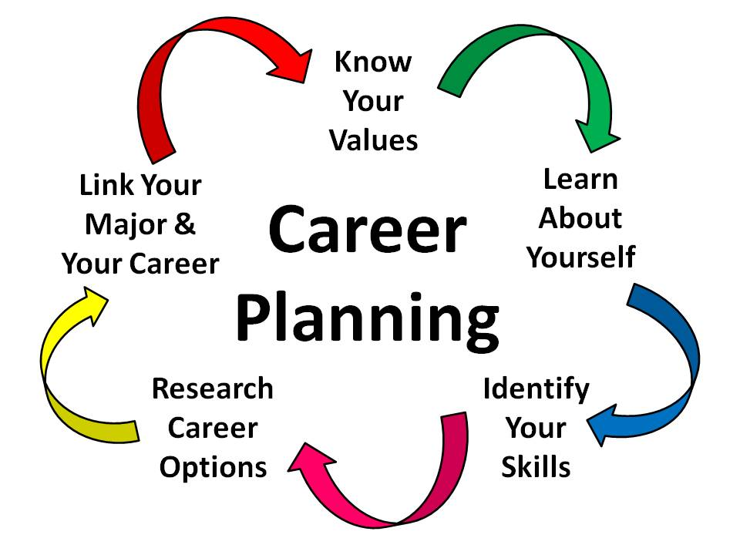
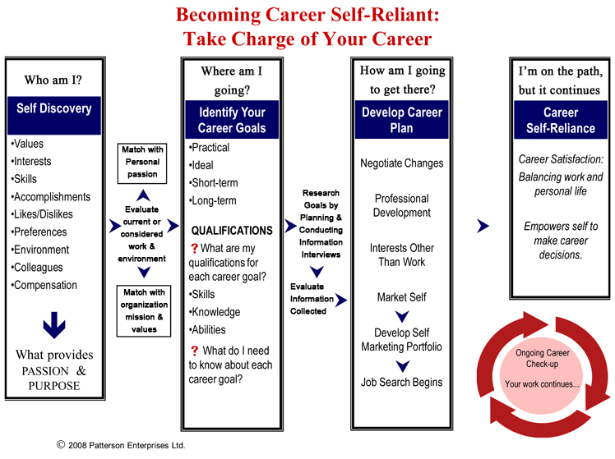

How to improve your English (language week, stay abroad, gap year ...)
https://www.learnenglish.de/improvepage.html
https://www.gooverseas.com/blog/pros-and-cons-taking-gap-year

